NTG SCHOOL
Student Attendance Management System
A graduation project dissertation by
[
Team leader: Abdulrahman
Coleader: Youssef Yasser
Team members is :
Rodina
Hager
Moaned
Ahmed Noor
Ahmed Hossam
]
January 2026

ACKNOWLEDGEMENT
No one can achieve their goal alone; we all live in a world where we need the help of each other to achieve our goals. This moment is one of our most valuable, remarkable, and important moments. We want to thank everyone who helped us get this project done.
First, we would like to thank our professor Nouran Yasser who was always there when we needed him the most. We want to thank him for encouraging us throughout the way till this moment; he gives us hope to carry on. It was such an honor to work under his supervision.
Then we are very grateful to our families for their support, encouragement, and patience with us. Furthermore, we acknowledge the staff and faculty at Helwan University for providing us with exceptional resources and educational opportunities. The environment and community they fostered played a crucial role in our growth and development. It was a great effort, and we are so grateful for this effort.

Chapter 1
Introduction
1.1 Overview
The Student Attendance Management System is designed to streamline and automate attendance tracking for educational institutions. The platform provides students with comprehensive tools to monitor their attendance records, view attendance percentages, access their class timetables, and manage their account security through password changes. Administrators gain powerful capabilities to manage student records, update attendance data, and oversee system operations efficiently. By digitizing the attendance process, the system eliminates manual errors, reduces administrative burden, and ensures accurate real-time data for academic decision-making.
1.2 Objectives
- Secure Student Authentication: Provide students with a secure login mechanism using username and password credentials, ensuring only authorized users can access their personal attendance information.
- Attendance Monitoring and Tracking: Enable students to view their calculated attendance percentages across configurable date ranges, and allow administrators to maintain comprehensive attendance records with real-time updates.
- Efficient Student Management: Equip administrators with tools to register, update, and delete student records through a structured interface, preventing duplicate entries and maintaining data integrity.
- Schedule Accessibility: Allow students to access their class timetables organized by semester or time period, helping them plan and manage their academic activities effectively.
- Account Security and Control: Permit students to change their passwords after verifying their current credentials, maintaining secure access to their accounts and personal information.
- Administrative Oversight: Provide administrators with full CRUD (Create, Read, Update, Delete) capabilities over attendance and student data, enabling complete control over system operations.
1.3 Purpose
Traditional paper-based and manual attendance systems are prone to errors, time-consuming, and inefficient for large student groups. The Student Attendance Management System addresses these challenges by automating the attendance tracking process. The primary goal is to provide educational institutions with a reliable, user-friendly platform that:
- Eliminates manual data entry errors and reduces administrative workload
- Provides students with immediate access to their attendance records
- Enables quick and accurate attendance percentage calculations
- Supports compliance with institutional attendance policies
- Generates reliable data for academic decision-making and student performance evaluation
By offering intuitive interfaces for both students and administrators, the system ensures accessibility across technical skill levels while maintaining robust data security.
1.4 Scope
The Student Attendance Management System encompasses the following core functionalities:
- User authentication and login management
- Student attendance viewing and percentage calculation with date filtering
- Password management and security updates
- Student lifecycle management (add, update, delete)
- Attendance record management (add, update, delete)
- Timetable retrieval and display
The system targets educational institutions with student and administrator user roles, focusing on core attendance management functions without advanced analytics or external system integrations in the initial release.
1.5 General Constraints
Time Constraint: Development follows an academic semester timeline with defined milestone deadlines for completion and deployment of system phases.
Scope Constraint: The initial release focuses on specified use cases. Future enhancements such as mobile applications, biometric tracking, and advanced analytics are outside the current scope.
Cost Constraint: The system utilizes free and open-source development tools and frameworks. Hosting costs are minimized through cost-effective infrastructure solutions. Budget constraints may impact server capacity scaling and premium feature development.
Data Collection Constraint: Attendance data relies on manual input from administrators. System requires internet connectivity for all operations. Data accuracy depends on consistent administrative data entry and validation processes.

Chapter 2
Planning and Analysis
2.1 Project Planning
2.1.1 Feasibility Study
Financial Feasibility
The Student Attendance Management System utilizes free and open-source development tools and frameworks, minimizing initial development costs. Hosting infrastructure can begin with free or low-cost services, with minimal bandwidth requirements for the application. Operational costs include routine maintenance and bug fixes. The long-term benefits—reduced manual administrative work, improved data accuracy, and enhanced student engagement—significantly outweigh operational expenses. The project is financially feasible for institutional adoption and scaling.
Technical Feasibility
The system is built using proven web development technologies including Angular for frontend development, Spring Boot for backend services, and relational databases for data persistence. All required technologies are freely available with comprehensive documentation and community support. The technical skills required for development and maintenance are standard in modern software development practices. Development timelines align well with chosen technology stacks, and the ease of implementation using these established frameworks supports project completion within scheduled deadlines. The project demonstrates strong technical feasibility.
Resource Feasibility
Required resources for the Student Attendance Management System include development devices (laptops/computers), internet connectivity for team collaboration, free hosting space for initial deployment, and freely available development tools (IDEs, version control systems, design software). The project team possesses the necessary programming expertise. All resource requirements are readily available and accessible. Resource feasibility requirements are fully satisfied.
Social and Legal Feasibility
The system uses freely available development tools and provides its service to authorized institutional users. All software libraries and frameworks are open-source with appropriate licensing. The system incorporates basic data privacy measures and role-based access control. Compliance with institutional data protection policies and educational regulations is built into the design. The project is socially and legally feasible.
2.3 Need for New System
Manual attendance tracking systems present significant limitations that justify implementing a digital solution:
- Error Prone: Manual record-keeping leads to calculation errors and data inconsistencies
- Time Consuming: Administrative staff spend substantial time on data entry and calculation
- Inefficient Reporting: Generating attendance reports requires manual compilation and compilation
- Limited Student Access: Students must request attendance information from administrators
- Scalability Issues: Manual systems struggle with large student populations
The digital Student Attendance Management System provides:
- Real-time attendance tracking and calculation
- Immediate student access to personal attendance data
- Automated attendance percentage calculations
- Administrator tools for efficient data management
- Scalable infrastructure supporting multiple users
- Audit trails and data integrity validation
2.4 Analysis of the System
2.4.1 User Requirements
For Students:
- User can login to the system using username and password credentials
- User can view their attendance percentage across selected date ranges
- User can change their password after verifying the current password
- User can view their class timetable organized by semester or time period
- User can track their attendance status (present/absent) over time
For Administrators:
- Admin can add new student records to the system with required information
- Admin can update existing student records when information changes
- Admin can delete student records when no longer needed
- Admin can view all attendance records for any student
- Admin can add new attendance records for students
- Admin can update existing attendance records
- Admin can delete attendance records when necessary
- Admin can generate attendance reports for compliance and analysis
2.4.2 Domain Requirements
- The database server must have sufficient memory and processing power to support multiple concurrent users without performance degradation
- The system must support updates and feature enhancements for future versions without complete rebuild
- All data inputs must be validated before storage in the database to ensure data integrity
- The system must accommodate updates for new user roles and permission levels
- Database backups must occur periodically to prevent data loss in case of system failures
- The system must enforce referential integrity between students, users, and attendance records
2.4.3 System Requirements
- Internet Connectivity: Broadband internet connection with at least 2 Mbps upstream bandwidth for file uploads and data synchronization
- Operating System: Support for modern web browsers including Chrome, Firefox, Safari, and Edge
- Server Environment: Web server supporting Java/Spring Boot deployment
- Database Server: MySQL or compatible relational database system
2.4.4 Functional Requirements
- Login: System validates student credentials against the database and creates authenticated sessions
- View Attendance Percentage: System retrieves attendance data, calculates working days and attended days, and displays percentage
- Change Password: System verifies current password, validates new password, and updates database
- View Timetable: System retrieves and displays student's class schedule by semester or time period
- Manage Students (Admin): System supports add, update, and delete operations for student records
- Manage Attendance (Admin): System supports view, add, update, and delete operations for attendance records
2.4.5 Non-Functional Requirements
Performance:
- The system shall respond to user requests within 3 seconds
- The system shall reliably handle concurrent users without delays
- Application startup time shall not exceed 6 seconds
Safety and Security:
- The system shall ensure only authorized users can access their data
- The system shall distinguish between student and administrator roles
- All user passwords shall be encrypted in the database
- Role-based access control shall restrict administrative functions to authorized users only
Usability:
- The system shall present a user-friendly interface requiring minimal training
- Navigation shall be intuitive for users of varying technical skill levels
- Form validation shall provide clear error messages guiding user corrections
Availability:
- The system shall be available 24 hours per day, 7 days per week
- System functionalities must remain accessible with minimal downtime
- Maintenance windows shall be scheduled during low-traffic periods
Reliability:
- The system shall not experience data validation failures
- Attendance records shall remain accurate and up-to-date
- Database transactions shall ensure data consistency and prevent corruption
Compatibility:
- Frontend and backend components must work seamlessly together
- Database and backend services must maintain compatibility for extended periods
- The system must support web browser compatibility across major platforms
2.5 Advantages of the System
- Automated Attendance Calculation: Eliminates manual percentage calculations, reducing errors and saving administrative time
- Real-Time Student Visibility: Students can view their attendance instantly without requesting information
- Complete Administrative Control: Administrators have full CRUD capabilities for both student and attendance data
- Data Integrity: Validation rules prevent duplicate records and ensure consistent data quality
- Scalability: Digital infrastructure scales easily to support growing student populations
- Accessibility: Web-based platform provides access from any device with internet connectivity
- Audit Trail: System maintains records of all attendance updates for compliance and accountability
- Role-Based Security: Ensures students access only their data while admins retain full oversight

Chapter 3
System Design

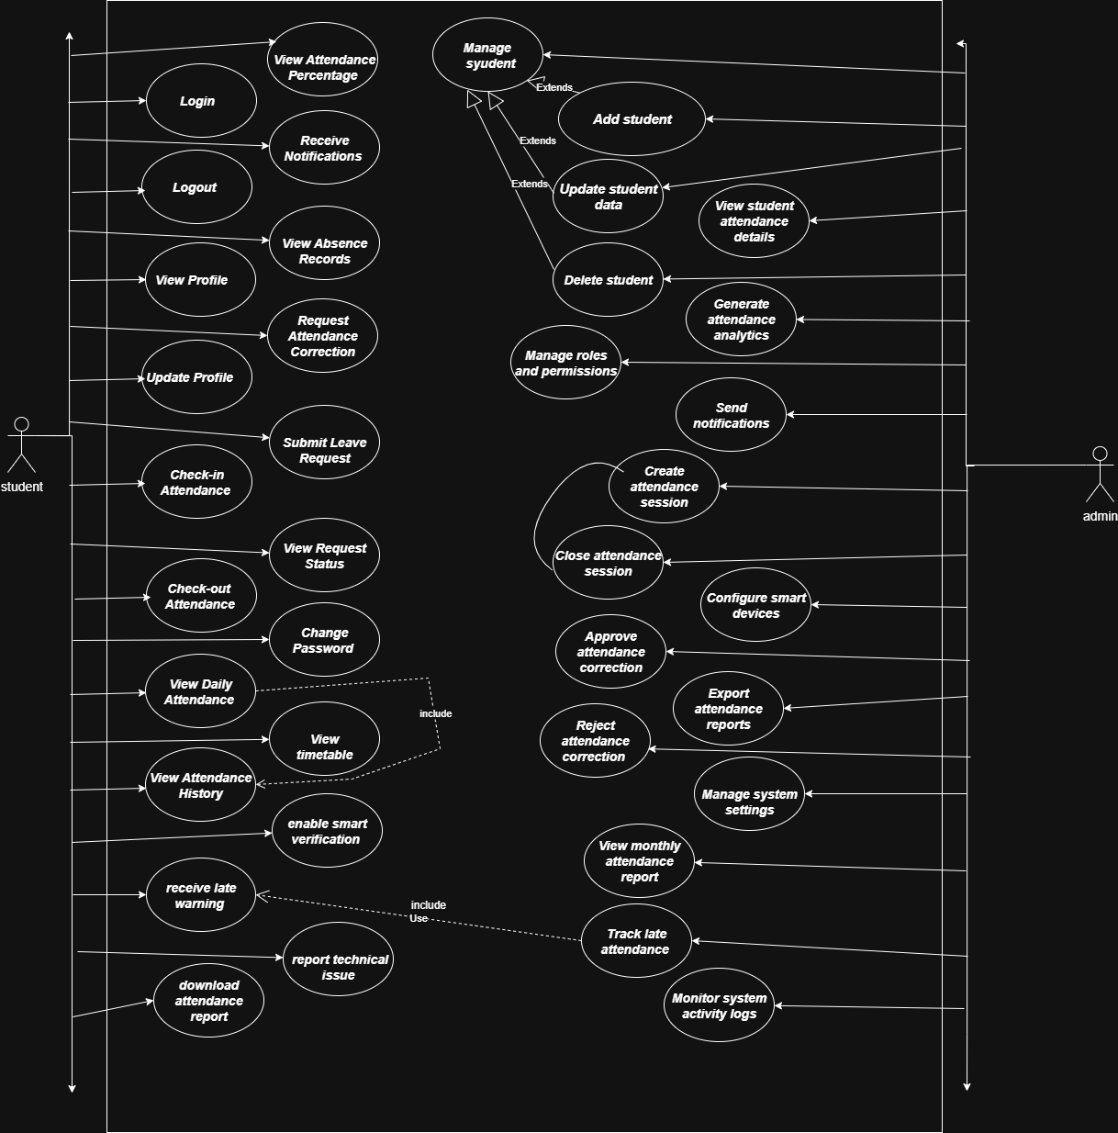

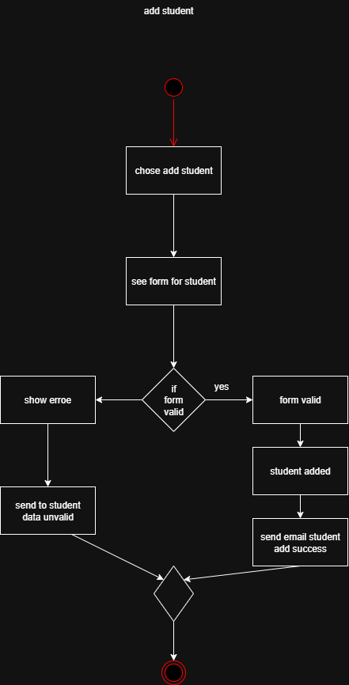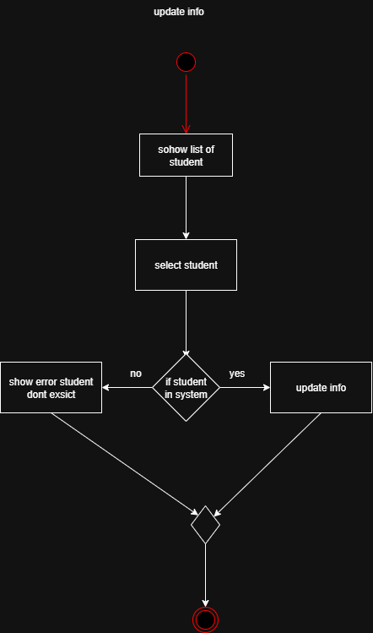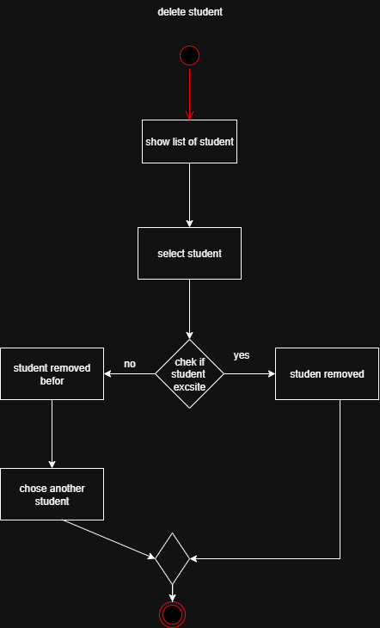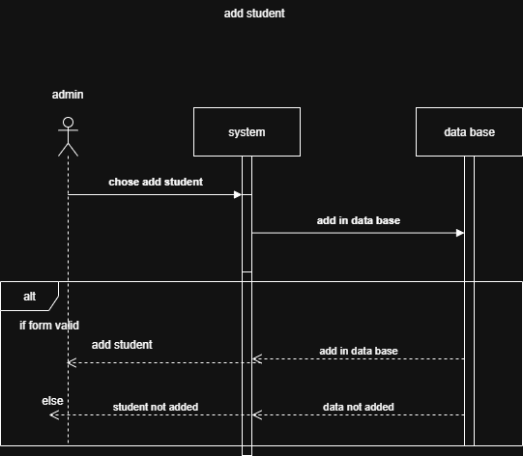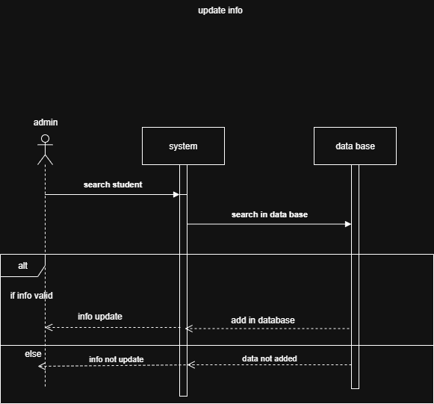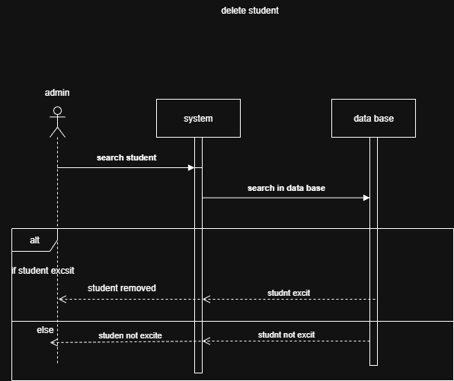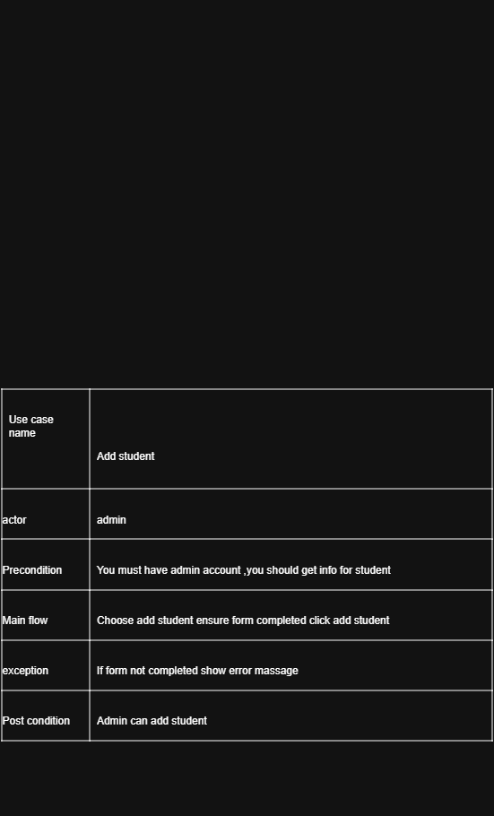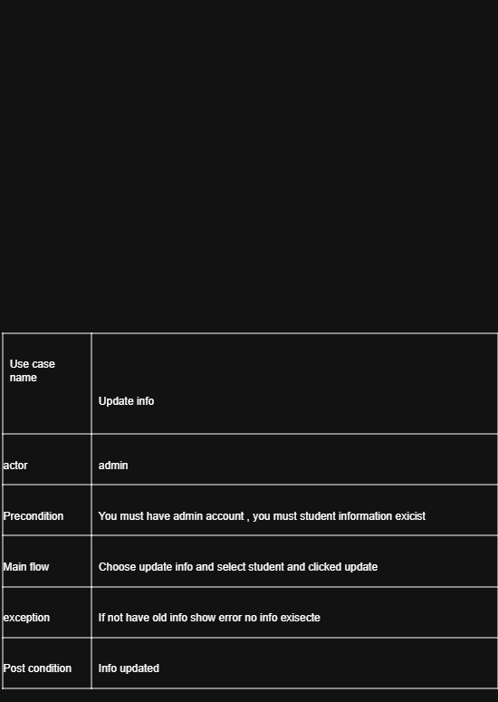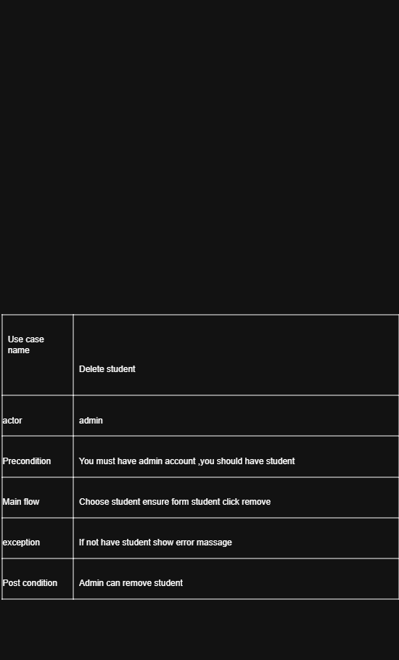
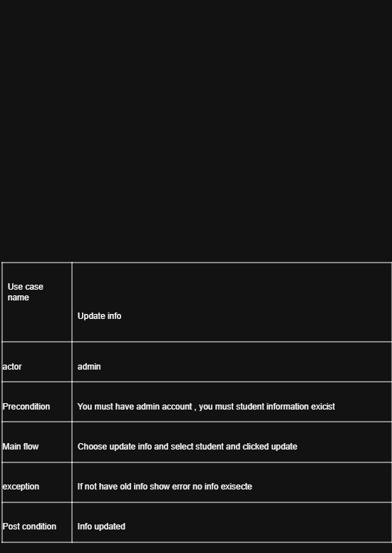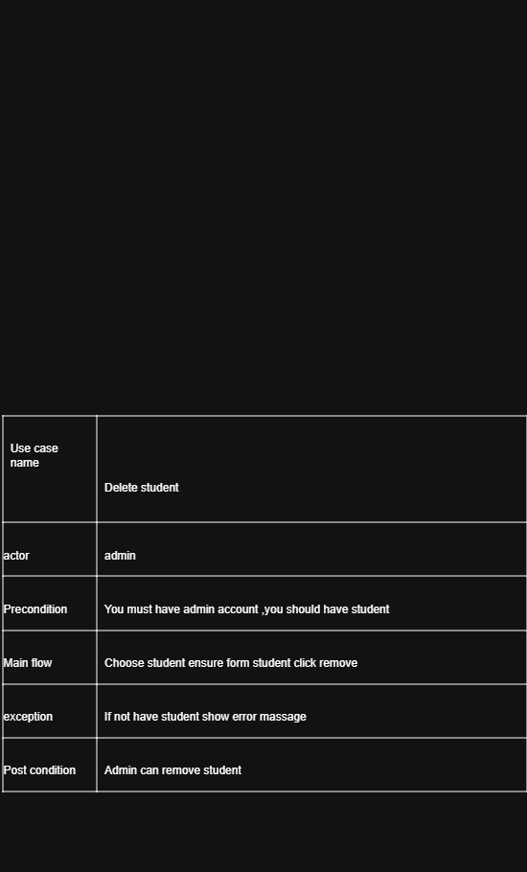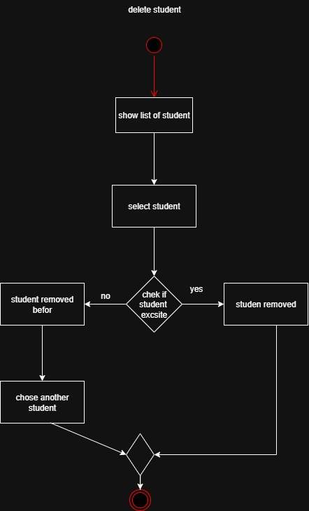

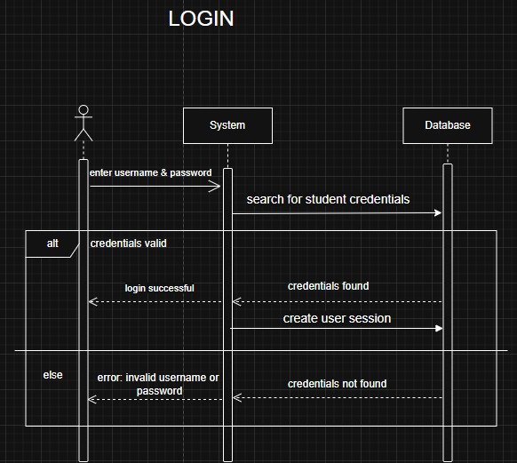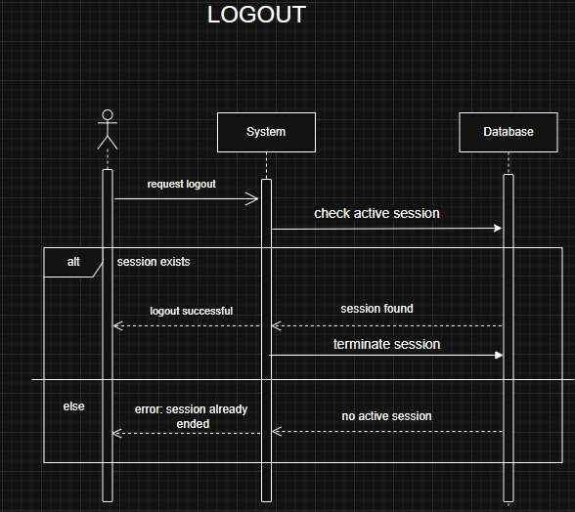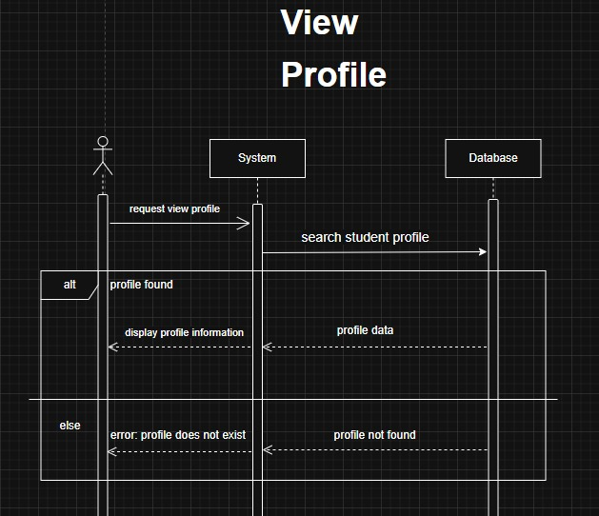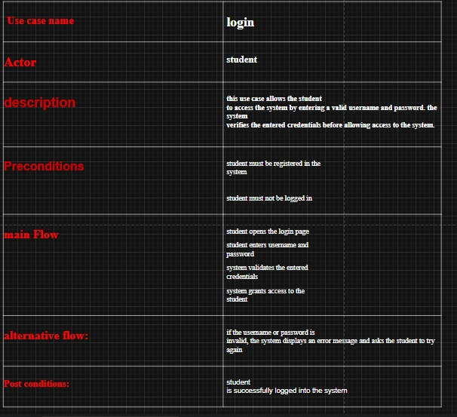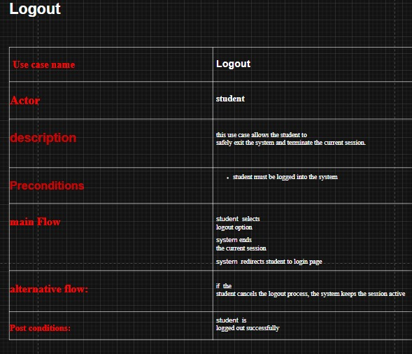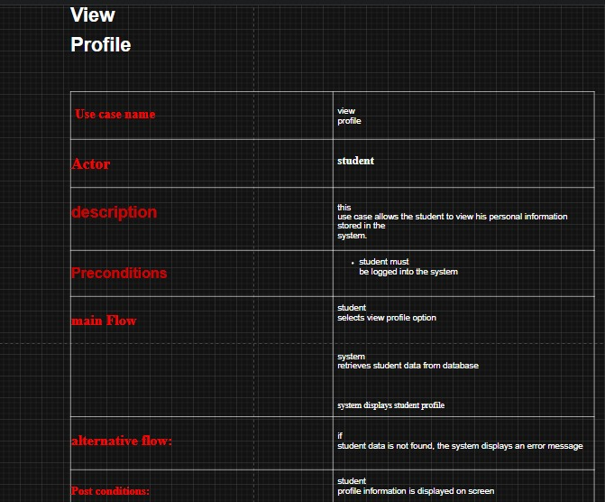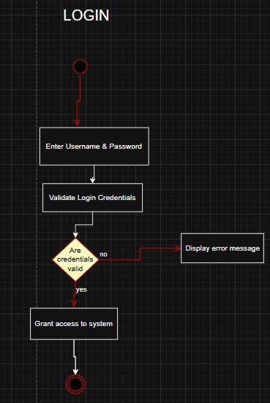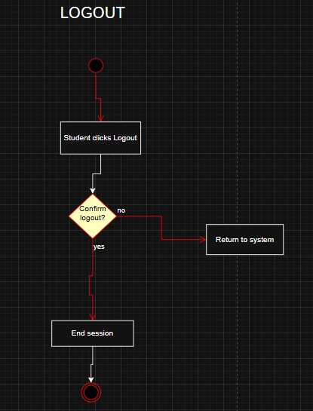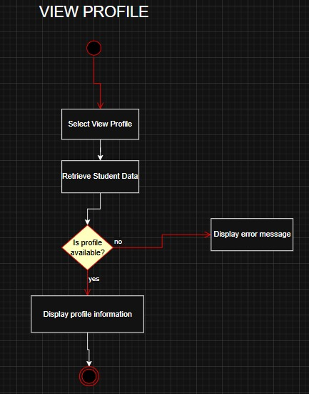

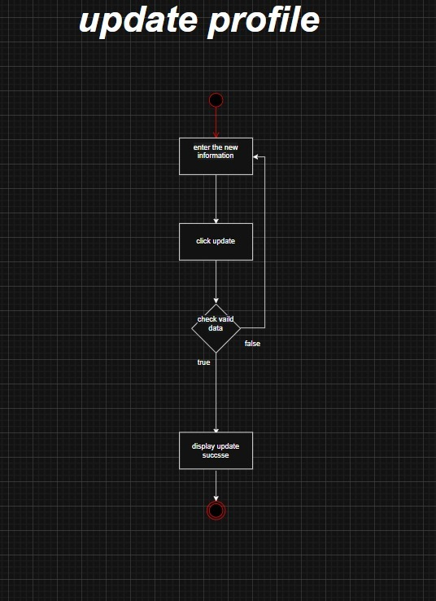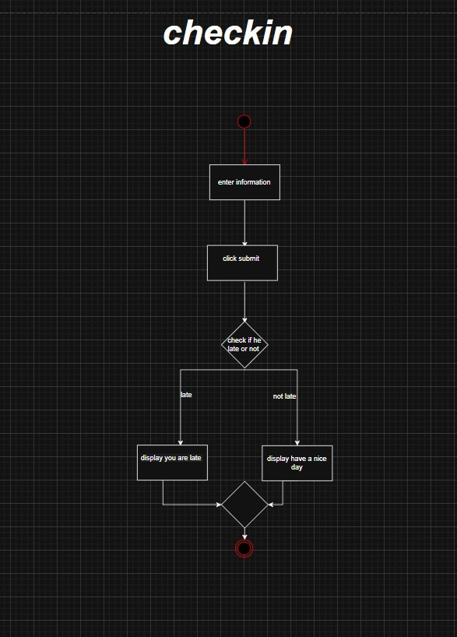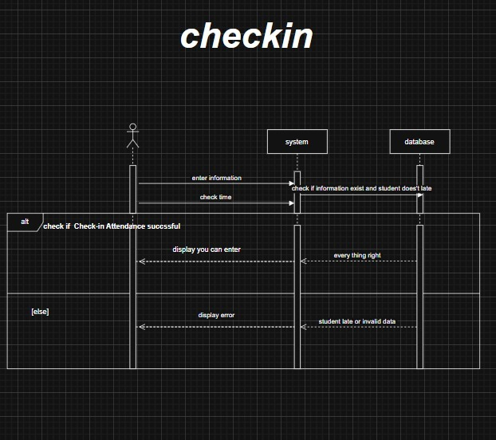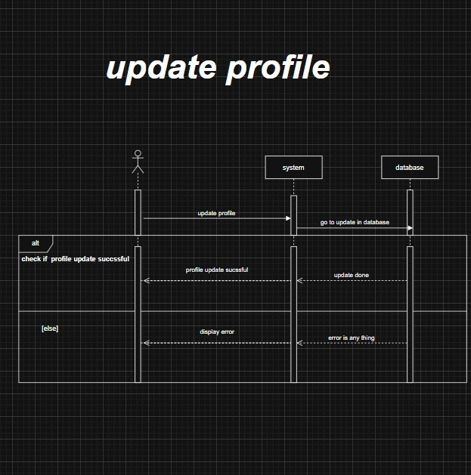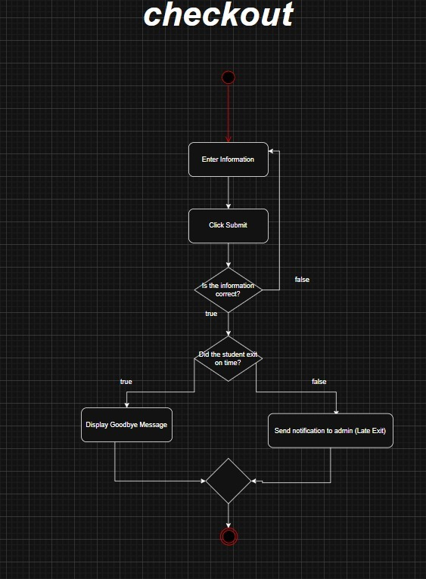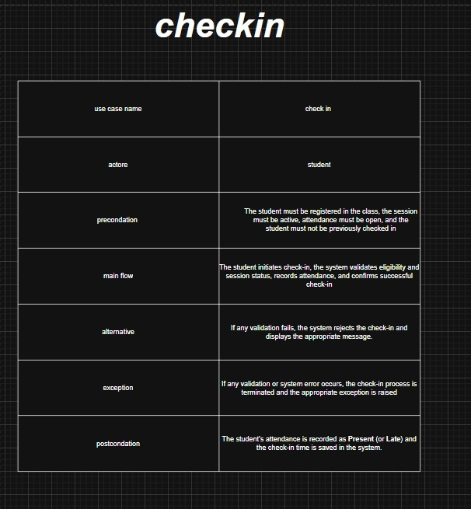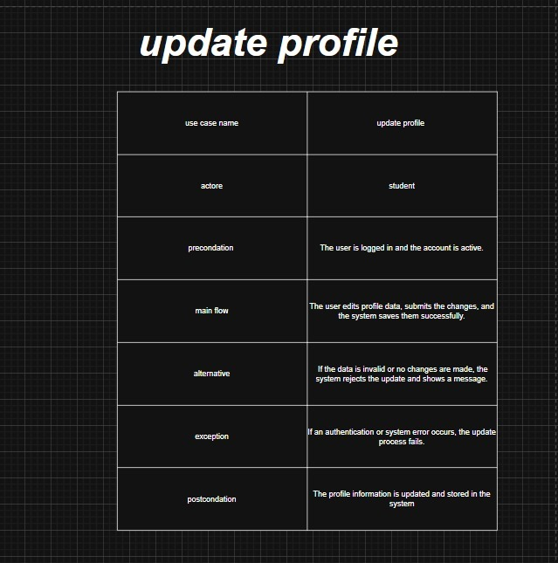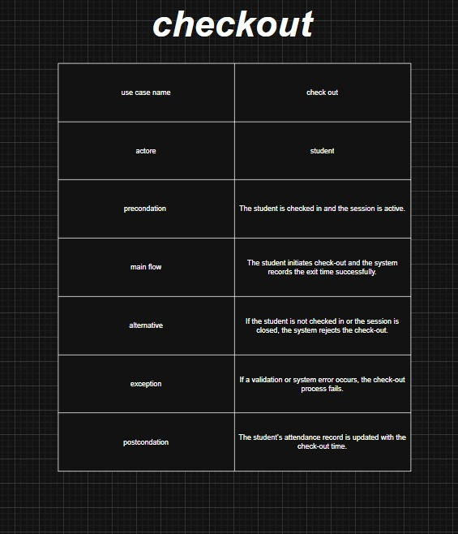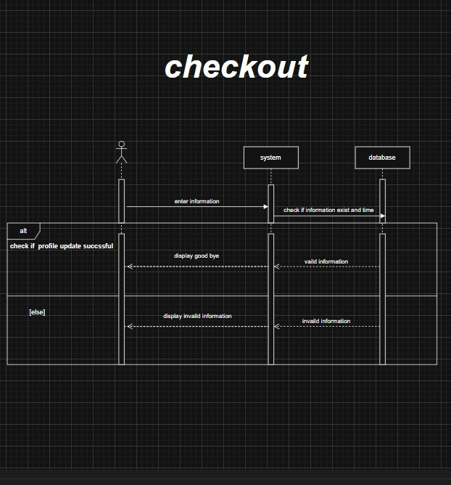

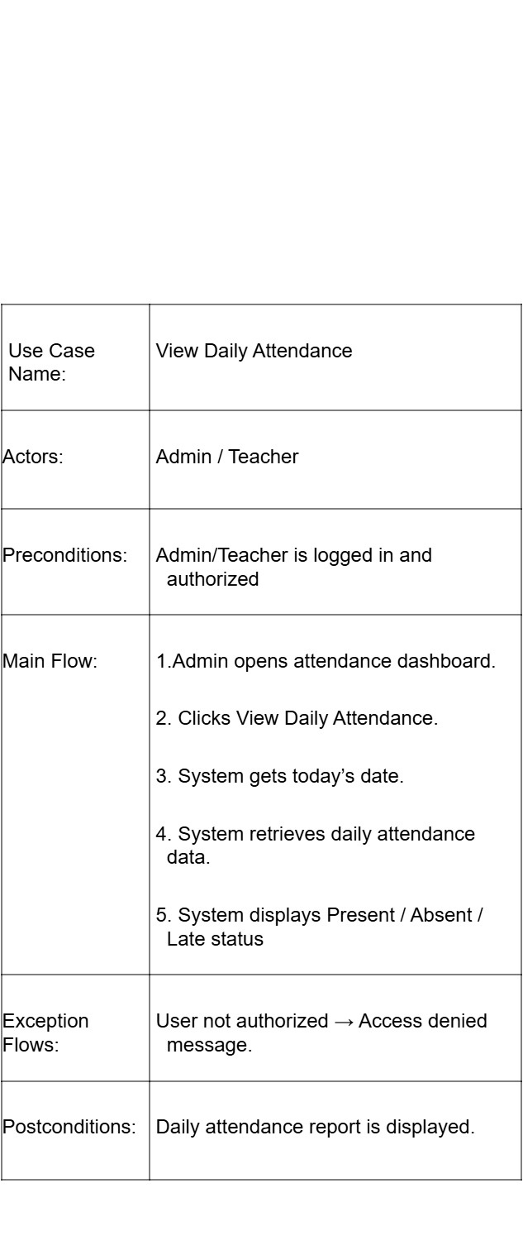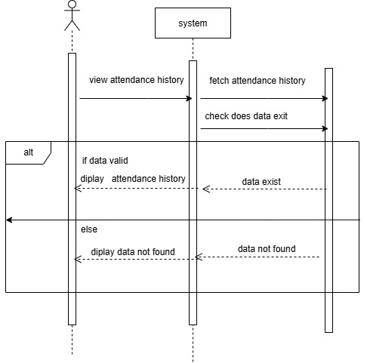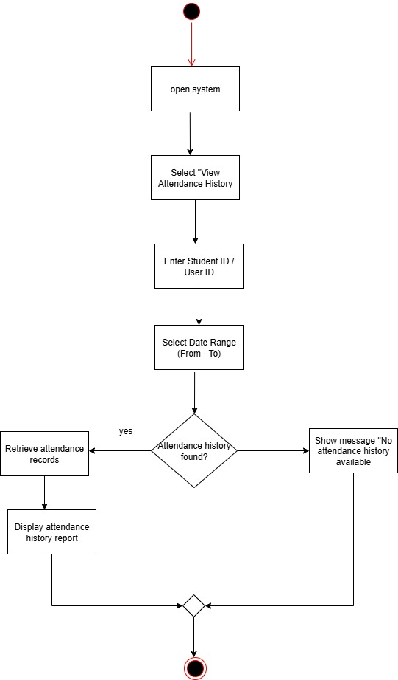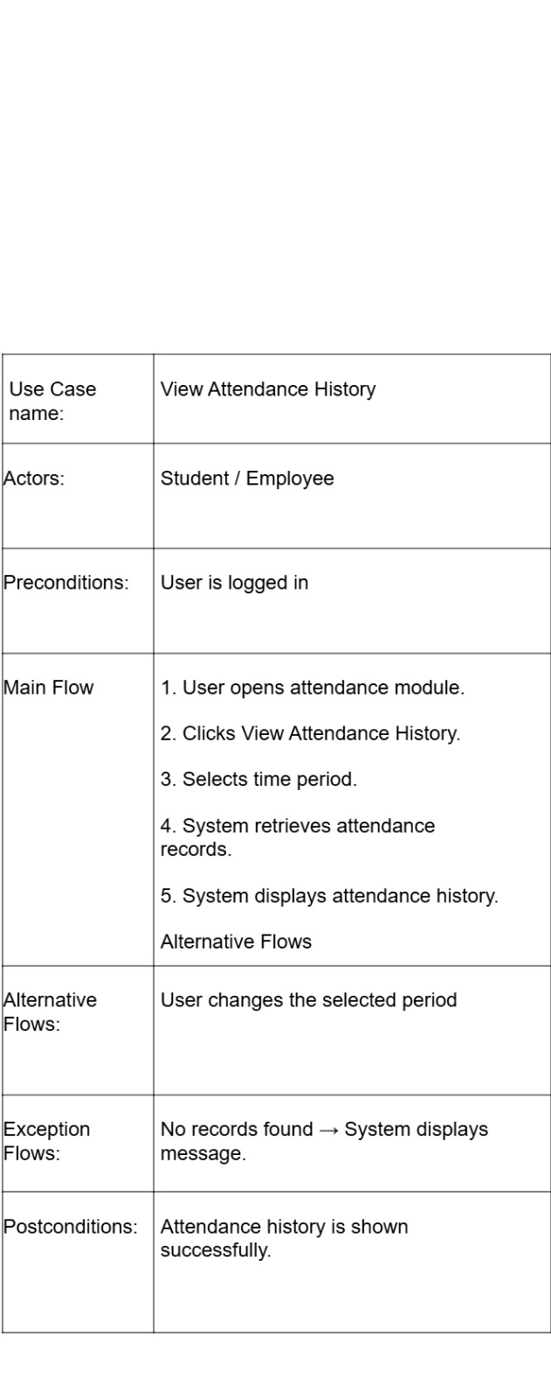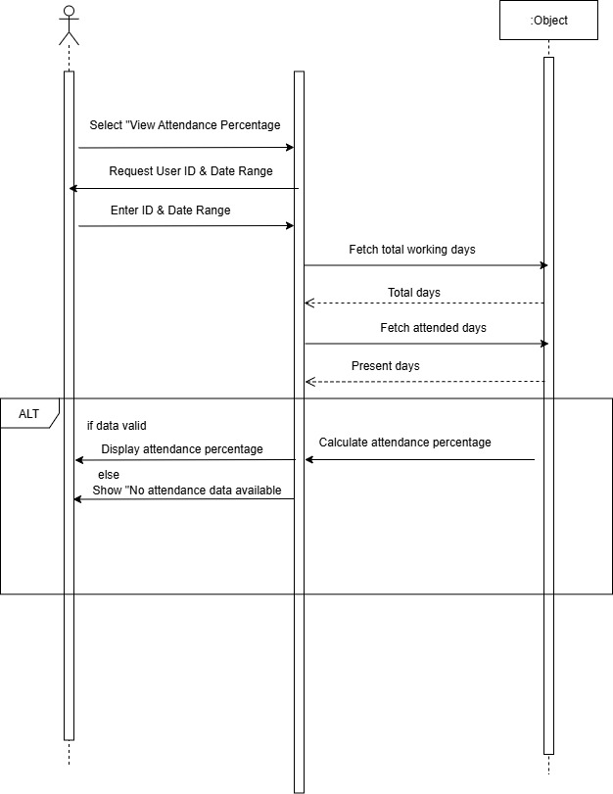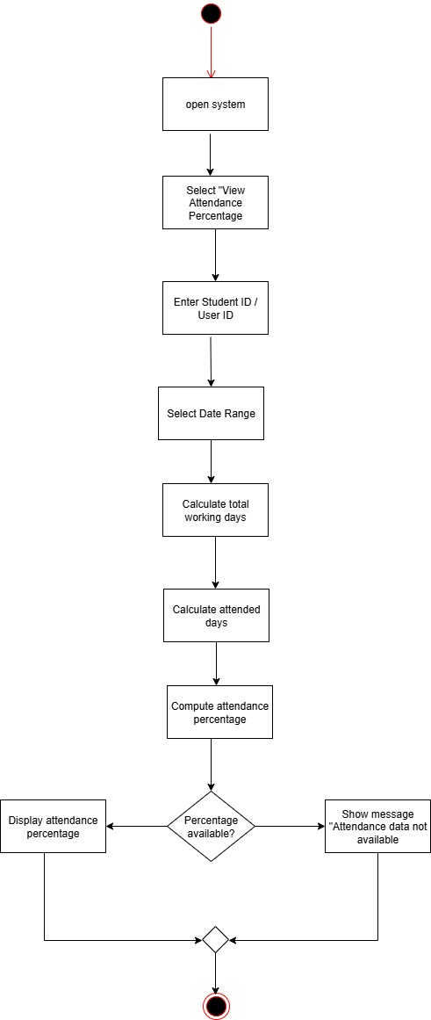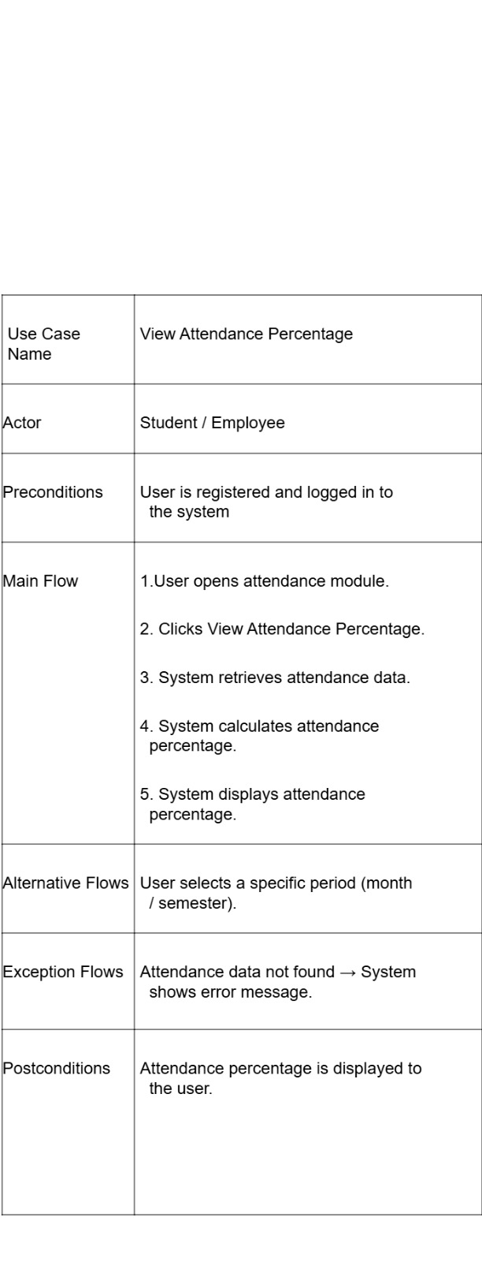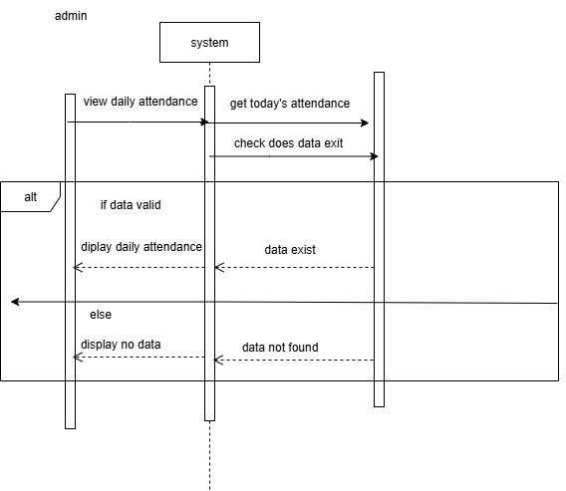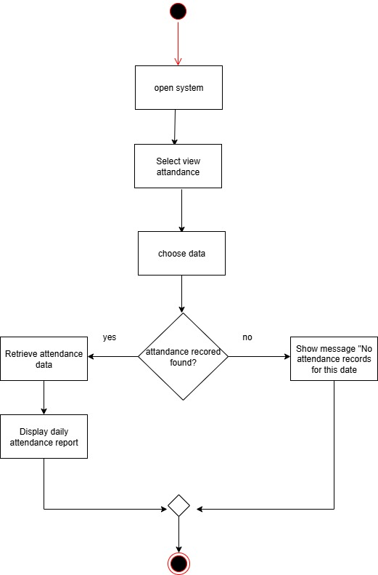

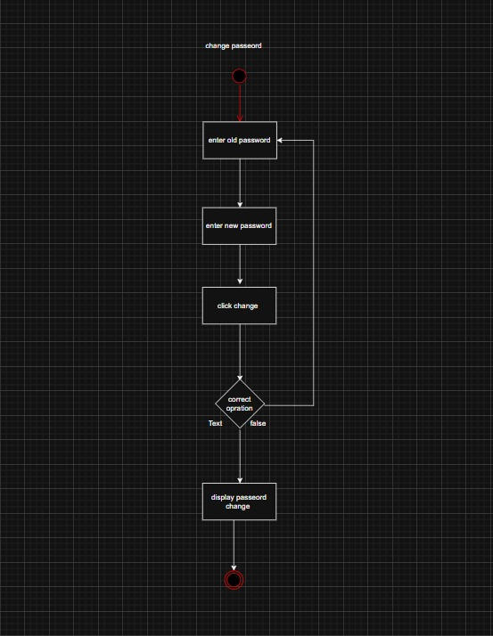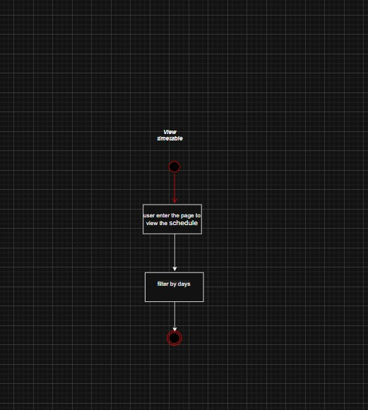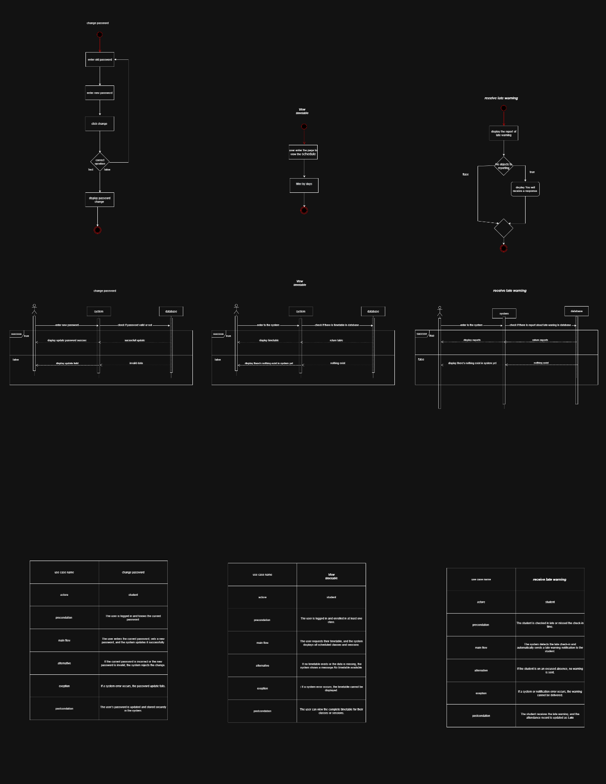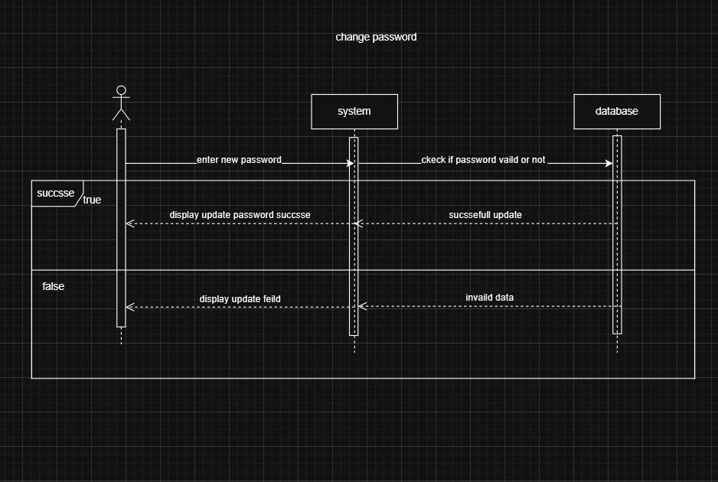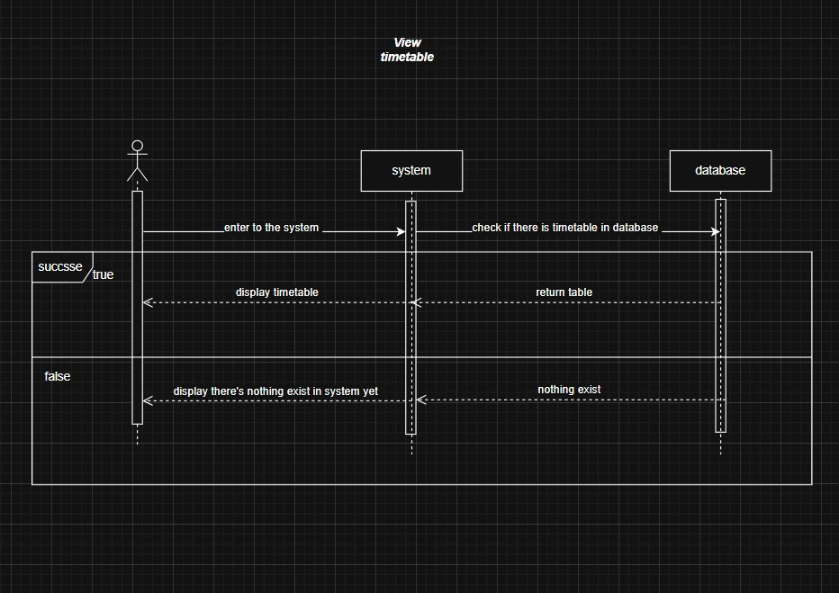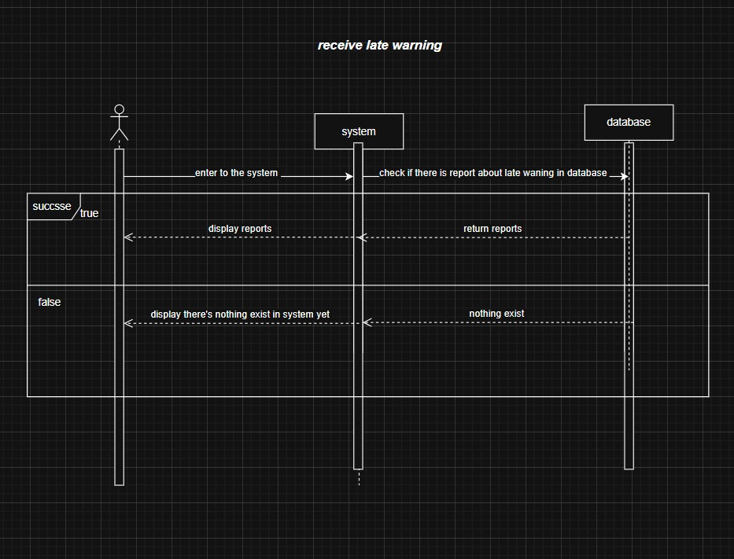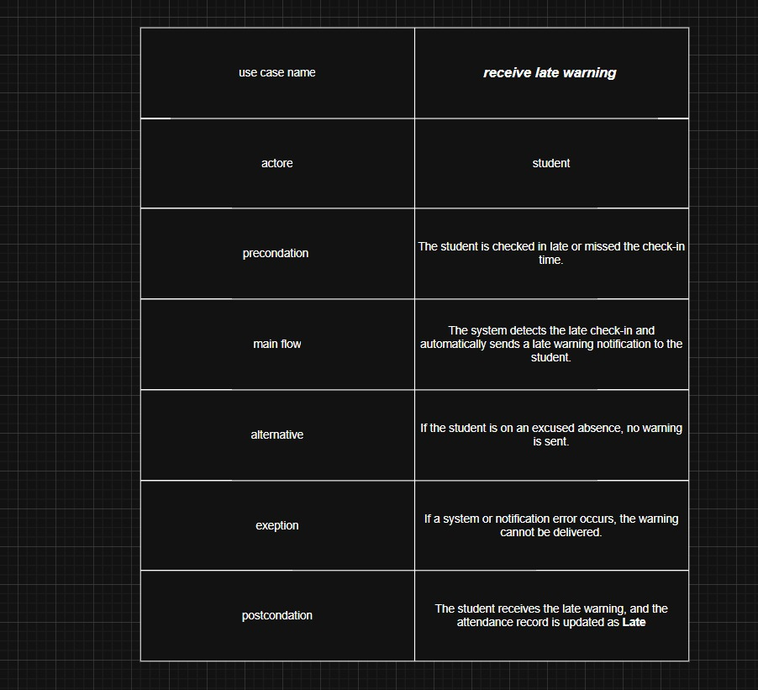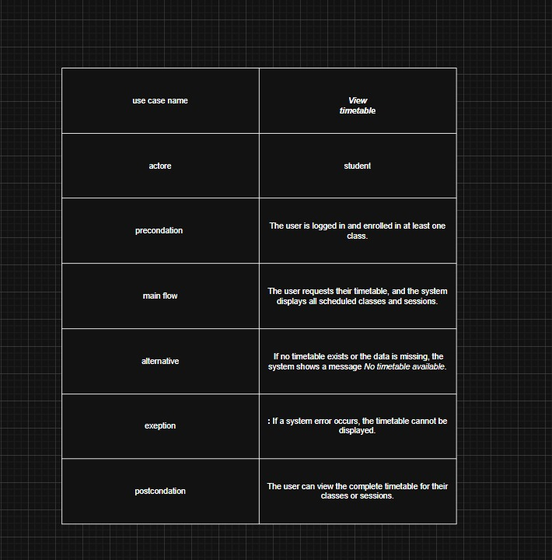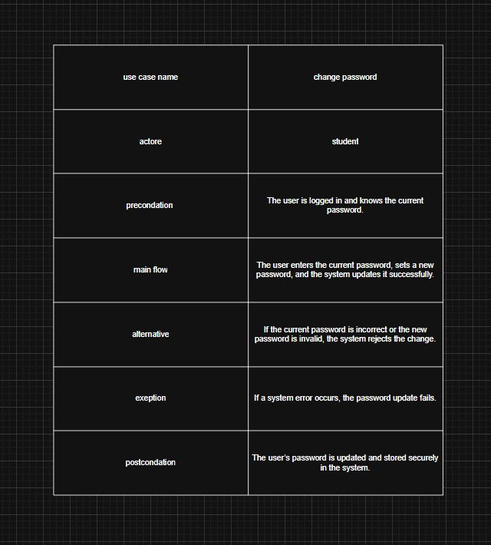

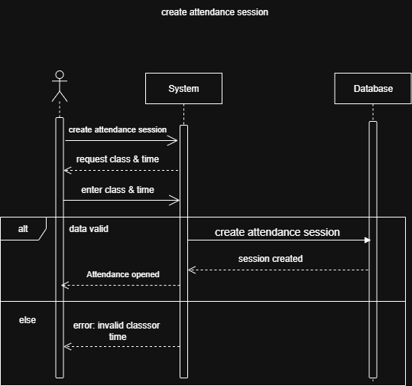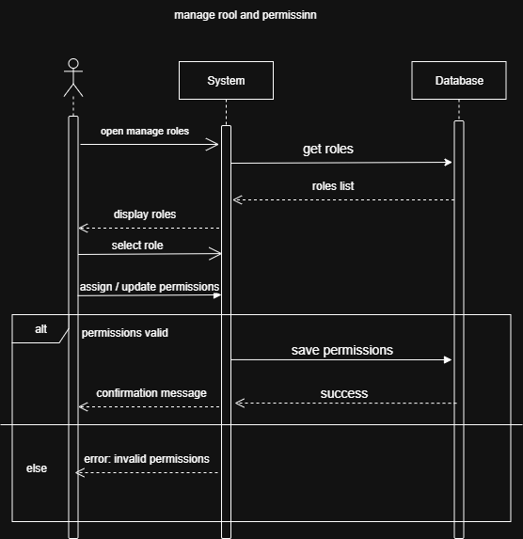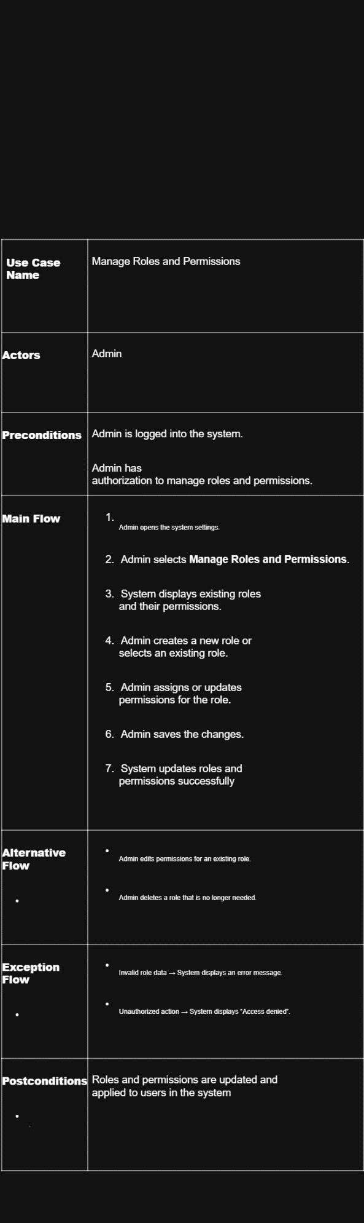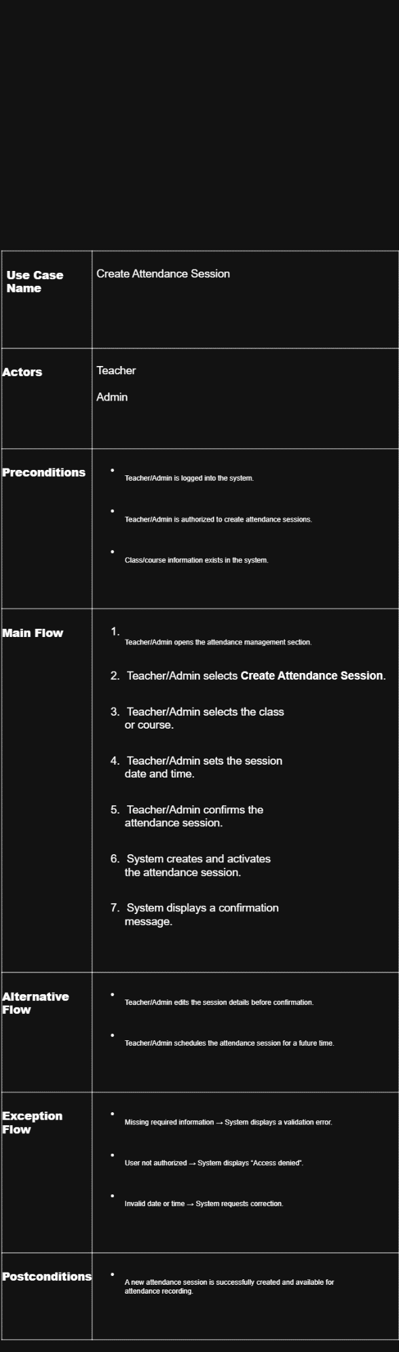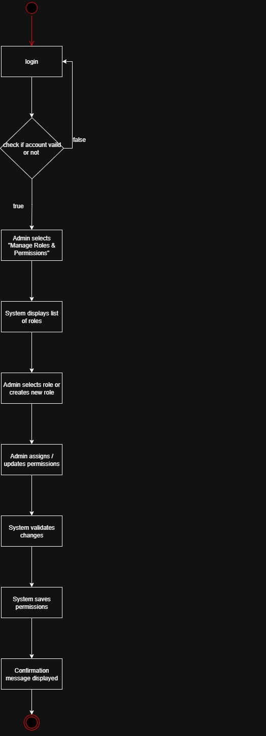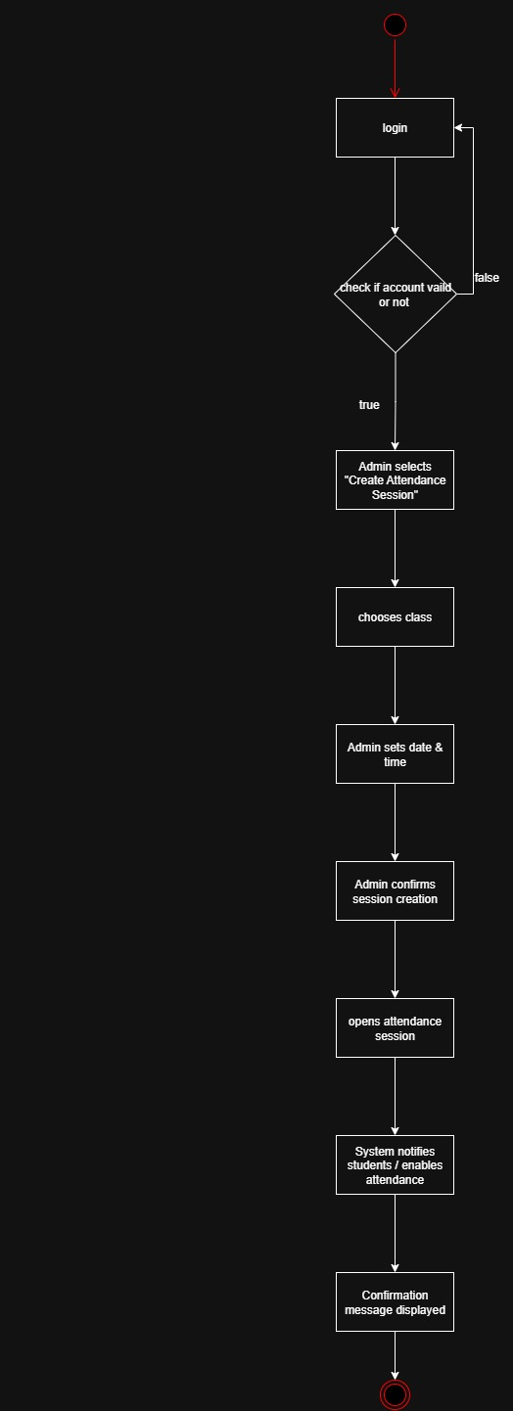

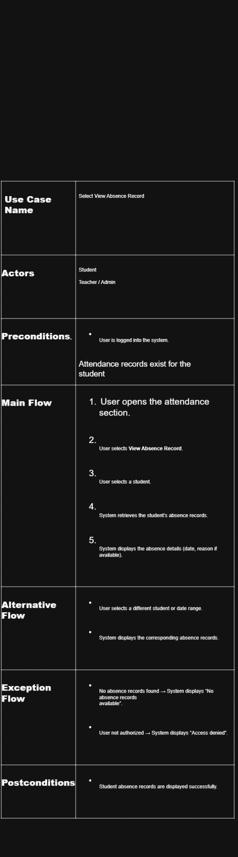
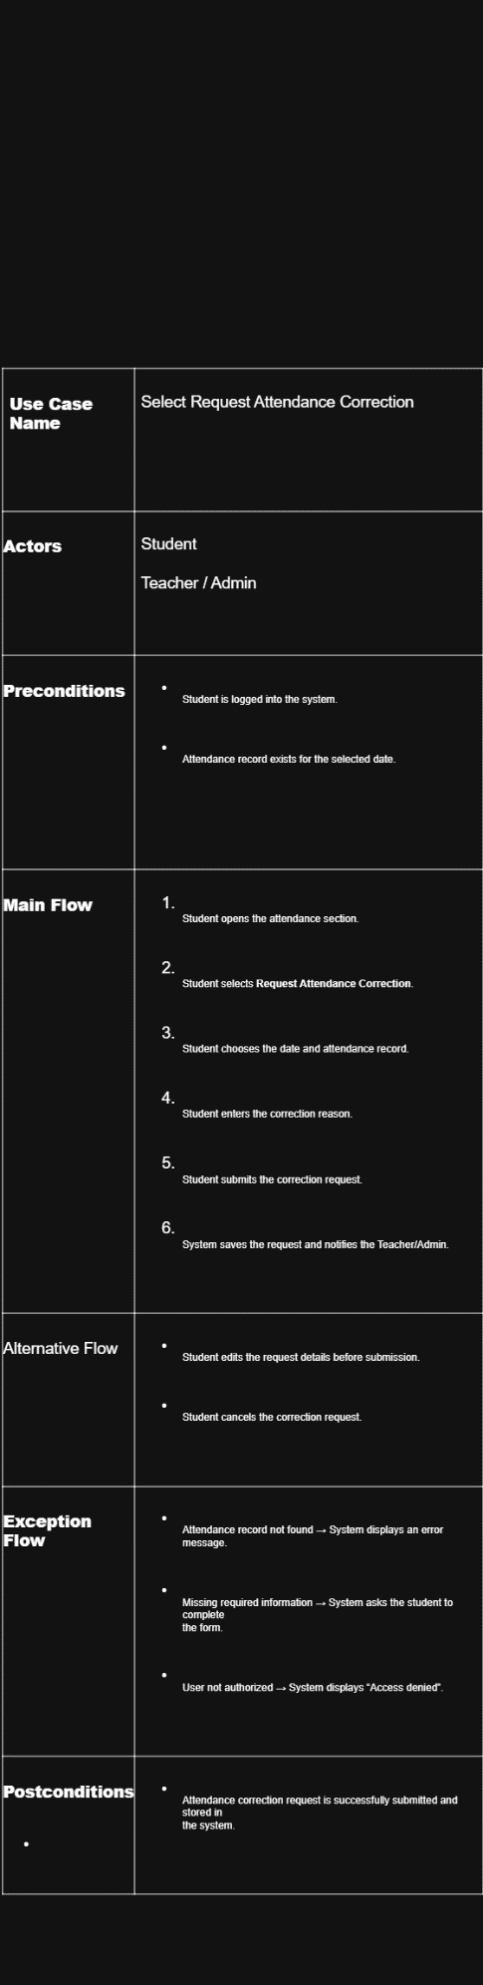
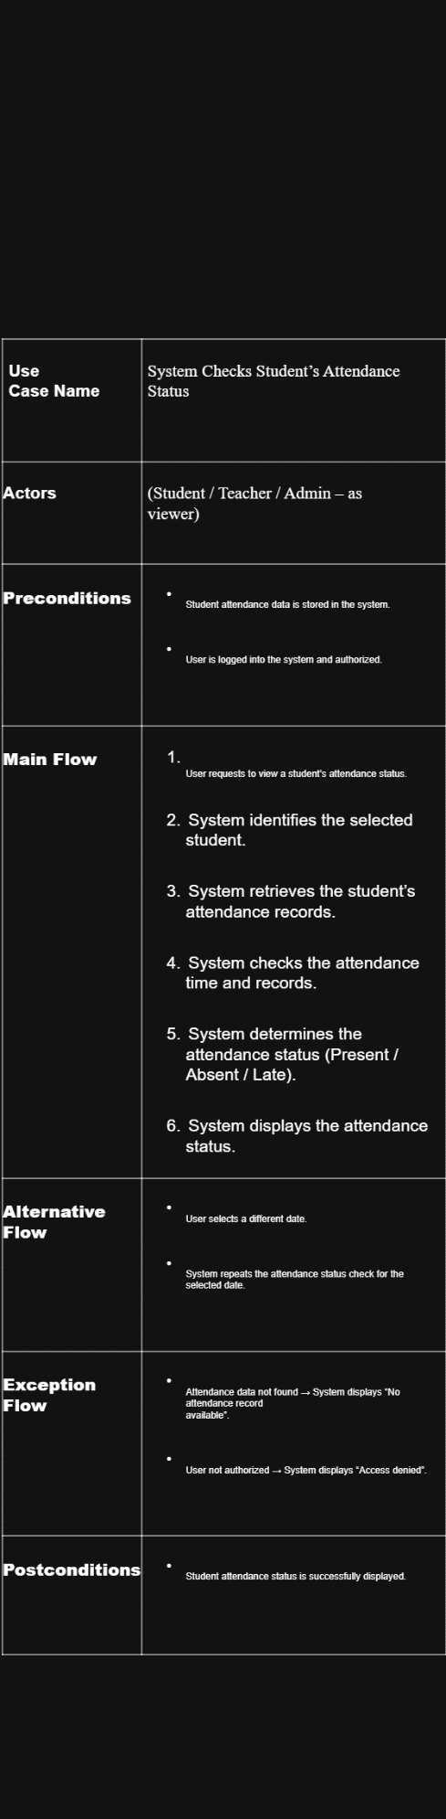
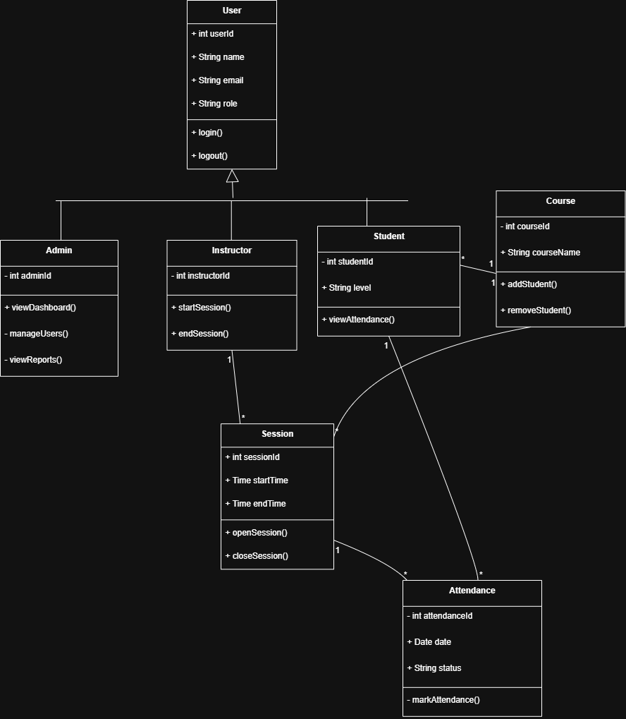

Chapter 4

Future Work
The Student Attendance Management System provides a solid foundation for attendance tracking with potential for significant enhancements:
- Mobile Application: Develop native iOS and Android applications for convenient access to attendance information
- SMS and Email Notifications: Send automated alerts to students with low attendance or upcoming deadline warnings
- Biometric Integration: Integrate fingerprint or facial recognition for automated attendance marking
- Advanced Analytics: Implement dashboards with trend analysis, attendance patterns, and predictive alerts
- Integration with Student Information System: Connect with institutional ERP systems for seamless data flow
- Bulk Import/Export: Enable administrators to import attendance data from spreadsheets or export reports in multiple formats
- Real-Time Notifications: Send instant notifications to students about their attendance status changes
- Custom Report Generation: Allow administrators to create customized reports with flexible date ranges and filtering
- Machine Learning Predictions: Implement models to predict students at risk of poor attendance
- Parent Portal: Enable parent access to their child's attendance information with notification settings

Chapter 5
Conclusion
The Student Attendance Management System successfully addresses the limitations of manual attendance tracking in educational institutions. By automating the attendance process, the system significantly reduces administrative burden, eliminates human errors, and provides students with immediate visibility into their attendance records.
The system's implementation using modern web technologies (Angular, Spring Boot, MySQL) ensures scalability, reliability, and ease of maintenance. Comprehensive testing across unit, integration, and system levels confirms functionality and performance. The role-based access control architecture maintains security while accommodating both student and administrator needs.
The Student Attendance Management System represents a significant advancement in institutional attendance management, providing a user-friendly platform that enhances both administrative efficiency and student accountability. With a solid technical foundation and clear path for future enhancements, the system is well-positioned for institutional adoption and continued evolution to meet emerging requirements.
By empowering students with access to their attendance data and equipping administrators with robust management tools, the Student Attendance Management System contributes to improved academic outcomes, enhanced institutional efficiency, and better data-driven decision-making in educational organizations.

